SOFTWARE REQUIREMENTS SPECIFICATION

**For**

**Pet Adoption System**

**Prepared by:-**

*RAMITA.V*

*ROOBIKA.V*

*SOUNDARYA.R*

# Introduction

# Purpose

# The purpose of a Pet Adoption System is to facilitate the adoption of animals, typically pets like dogs, cats, and other companion animals, from shelters or rescue organizations.

# Animal Welfare: The primary goal is to ensure the well-being and welfare of animals. By providing a structured adoption process, these systems aim to reduce the number of stray or abandoned animals and give them a chance for a better life.

# Promoting Responsible Pet Ownership: Adoption systems often include screening processes to ensure that potential adopters are capable of providing a loving and stable environment for the pet. This helps promote responsible pet ownership and reduces the likelihood of animals being returned or abandoned again.

# Matching Animals with Suitable Homes: The adoption process involves assessing the needs, characteristics, and personalities of both animals and potential adopters. The goal is to match animals with homes that can meet their specific requirements, increasing the likelihood of successful and lasting adoptions.

# Reducing Overpopulation: By encouraging adoption instead of purchasing pets from breeders or pet stores, adoption systems contribute to the reduction of overpopulation in shelters and communities. This, in turn, helps alleviate the burden on animal welfare organizations.

# Educating the Public: Pet adoption systems often play a role in educating the public about responsible pet care, the benefits of adoption, and the importance of spaying and neutering to control the pet population.

# Community Health and Safety: Stray animals can pose risks to public health and safety. By facilitating the adoption of these animals, the system helps address these concerns and contributes to creating safer communities.

# Emphasizing Compassion and Empathy: Pet adoption systems foster a sense of compassion and empathy toward animals. They encourage individuals and families to open their hearts and homes to animals in need, promoting a more humane society.

## +

## Scope of Development Project

## The scope of a pet adoption system project encompasses the boundaries and features that define what the system will and will not include. Defining the scope is a crucial step in project management, as it helps set expectations, allocate resources, and ensure the project's success

## Integration Requirements:

## Payment Integration: If the system involves adoption fees or donations, specify how payment processing will be integrated securely.

## External Systems: Identify any external systems, such as microchipping databases or third-party services, that need to be integrated.

## Constraints:

## Budget: Define budget constraints for the project, including development costs, maintenance, and potential future enhancements.

## Timeline: Establish a project timeline with milestones and deadlines for key deliverables.

## Regulatory Compliance: Identify and comply with relevant regulations related to pet adoption and data protection.

## Assumptions and Dependencies:

## Assumptions: Document any assumptions made during project planning that could impact the scope.

## Dependencies: Identify dependencies on external factors, such as third-party APIs or data sources.

## Definitions, Acronyms and Abbreviations

PAS: Pet Adoption System

PAAS: Pet Adoption and Assistance System

PATS: Pet Adoption Tracking System

PAWS: Pet Adoption Web System

PACOS: Pet Adoption and Care

## References

* + - Books

"Building Microservices: Designing Fine-Grained Systems" by Sam Newman

"Domain-Driven Design: Tackling Complexity in the Heart of Software" by Eric Evans

"Clean Code: A Handbook of Agile Software Craftsmanship" by Robert C. Martin

* + - Websites

**Flask Documentation: Flask Documentation**

**Django Documentation: Django Documentation**

**MongoDB Documentation: MongoDB Manual**

**REST API Design Guide: RESTful API Design Guide**

# Overall Descriptions

## Product Perspective

Use Case Diagram of Pet Adoption System

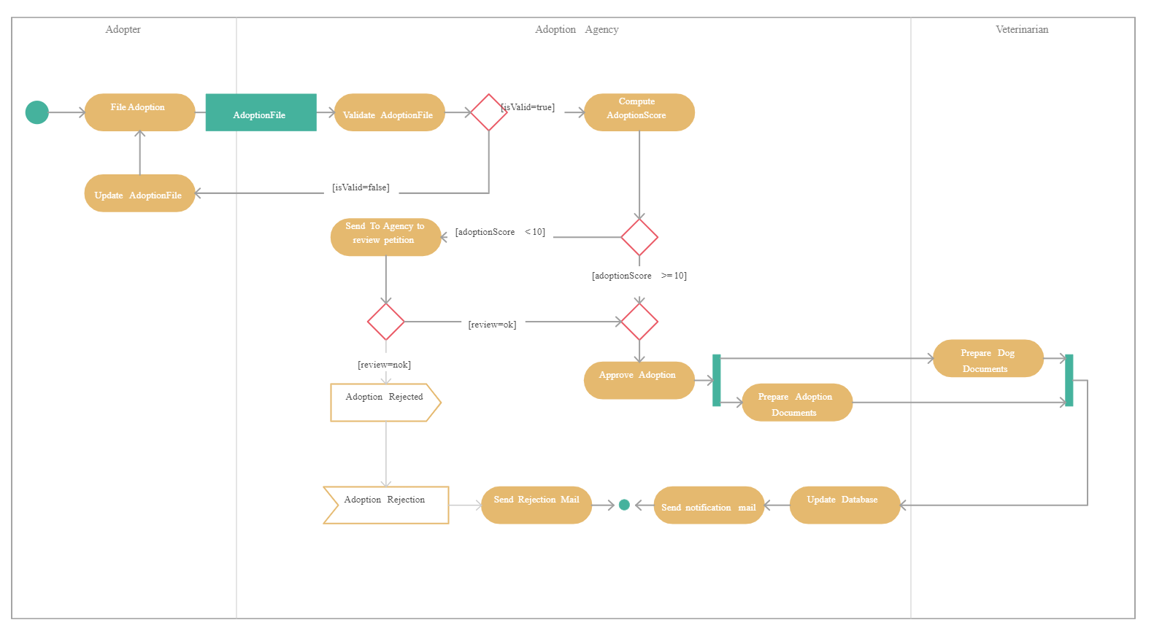

## Product Function

Entity Relationship Diagram of Pet Adoption System

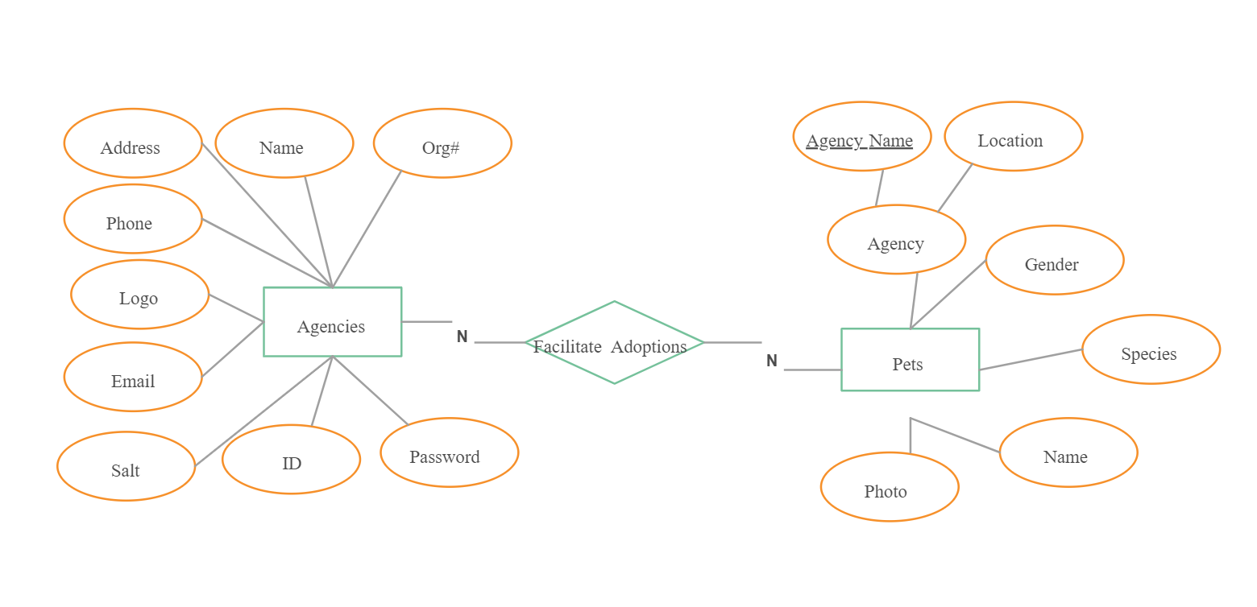

The product functions of a Pet Adoption System involve a range of features and capabilities to facilitate the adoption process, manage pet information, and provide a seamless experience for both users and administrators. Here are key product functions for a Pet Adoption System:

User Registration and Authentication:

Allow users to create accounts, providing necessary information, and authenticate securely to access the system.

Pet Listing and Details:

Display a comprehensive list of available pets for adoption, including detailed information such as breed, age, size, and health status.

## User Classes and Characteristics

## In a pet adoption system, there are typically several user classes with distinct characteristics. These user classes represent different roles and responsibilities within the system. Here are common user classes and their characteristics for a pet adoption system:

## Adopter:

## Characteristics:

## Individuals or families interested in adopting a pet.

## May have preferences for pet characteristics such as species, breed, age, etc.

## Submits adoption applications and provides necessary information for screening.

## Has the ability to view available pets, initiate adoption processes, and communicate with shelter staff.

## Shelter Staff:

## Characteristics:

## Employees or volunteers working in animal shelters or rescue organizations.

## Manages pet listings, including adding new pets, updating information, and removing adopted pets.

## Screens and evaluates adoption applications submitted by adopters.

## Communicates with adopters, providing information and coordinating the adoption process.

## Administrator:

## Characteristics:

## System administrators responsible for overseeing the entire pet adoption system.

## Manages user accounts, including creating, updating, and deleting accounts.

## Ensures system security, compliance with regulations, and proper functioning.

## Generates reports on system usage, adoption statistics, and other relevant metrics.

## Visitor (Non-Registered User):

## Characteristics:

## Individuals who visit the pet adoption system without creating an account.

## Can view general information about the system, available pets, and adoption procedures.

## May not have access to certain features reserved for registered users (adopters, shelter staff, and administrators).

## External System (e.g., Payment Gateway):

## Characteristics:

## Represents external systems or services integrated into the pet adoption system.

## Example: A payment gateway for processing adoption fees or donations.

## Communicates with the pet adoption system to facilitate specific functionalities.

## Operating Environment

The operating environment for a pet adoption system encompasses the technological, organizational, and regulatory aspects that influence the system's development, deployment, and ongoing functionality. Here are key considerations for the operating environment of a pet adoption system:

Technological Infrastructure:

Database Management: The system requires a robust database to store and manage information about animals available for adoption, adopters, and adoption histories.

Web Development: Many pet adoption systems operate online, requiring a well-designed and user-friendly website or application for potential adopters to browse available animals and submit adoption applications.

Integration with Other Systems: Integration with payment gateways, communication tools, and possibly microchipping systems can enhance the efficiency of the adoption process.

Data Security and Privacy:

Compliance with Regulations: The system must adhere to data protection regulations to ensure the security and privacy of sensitive information, such as adopters' personal details.

Secure Transactions: If the system handles financial transactions, it needs to implement secure payment processing to protect adopters' payment information.

User Support and Training:

Training for Staff: Shelter staff and administrators should be trained on using the system effectively to manage animal records, process applications, and update the website.

User Support: Providing adopters with support, such as FAQs, help guides, and possibly customer service channels, ensures a positive user experience.

Regulatory Compliance:

Adoption Regulations: The system should be designed to comply with local and national regulations governing pet adoption to ensure legal and ethical practices.

Reporting Requirements: It may be necessary to generate reports for regulatory purposes, such as tracking adoption statistics or providing data for inspections.

Community Outreach and Integration:

Social Media Integration: Leveraging social media platforms can enhance outreach efforts, allowing the system to reach a broader audience and increase the chances of successful adoptions.

Collaboration with Other Organizations: Integration with other animal welfare organizations, veterinary services, and local authorities can create a more comprehensive network for animal care.

Scalability and Flexibility:

Adaptability to Growth: The system should be designed to handle increased data and user volumes as the organization grows and more animals are added to the system.

Modular Design: A modular and flexible architecture allows for easy updates and additions to accommodate evolving needs and technological advancements.

Public Awareness and Education:

Content Management: The system may include features for publishing educational content about responsible pet ownership, adoption success stories, and other relevant information to engage and inform the public.

Community Engagement Tools: Features that encourage community participation, such as forums or events, can contribute to building a supportive and informed adopter community.

Accessibility and Inclusivity:

Multilingual Support: If applicable, providing multilingual support ensures accessibility for a diverse community of potential adopters.

Accessibility Features: The system should be designed with accessibility features to accommodate users with different abilities.

## Assumptions and Dependencies

The assumptions are:-

Assumption: Veterinary services are available to ensure the health and well-being of pets before and after adoption.

Dependency: The system relies on timely and quality veterinary care for health assessments, vaccinations, and spaying/neutering.

Assumption: Legal Compliance

Assumption: The organization adheres to legal requirements and regulations related to pet adoption, ensuring compliance with animal welfare laws.

Dependency: The system design and processes depend on adherence to local, regional, and national laws governing pet adoption.

Assumption: Internet Connectivity

Assumption: Users and administrators have consistent access to the internet for system usage.

Dependency: The Pet Adoption System operates as an online platform, relying on internet connectivity for user interactions, updates, and data storage.

Assumption: User Truthfulness in Applications

Assumption: Adopters provide truthful and accurate information in their adoption applications.

Dependency: The effectiveness of the adoption process relies on the accuracy of information provided by adopters for suitable matches and home visits.

Assumption: Availability of Volunteers

Assumption: Sufficient volunteers are available to assist with tasks such as home visits, events, and administrative duties.

Dependency: The system's efficiency depends on the availability and commitment of volunteers to carry out essential tasks.

Assumption: Public Awareness and Participation

Assumption: There is public awareness and participation in pet adoption and responsible ownership.

Dependency: The success of adoption events, education programs, and the overall system depends on public engagement and support.

Assumption: Cooperation from Animal Welfare Organizations

Assumption: Collaboration and cooperation exist with other animal welfare organizations for pet transfers and shared resources.

Dependency: The system relies on collaborative efforts for the seamless transfer of pets and shared information.

Assumption: Availability of Funding

Assumption: Adequate funding is available to support the operational costs of the Pet Adoption System.

Dependency: The system's sustainability depends on financial resources for hosting, maintenance, marketing, and veterinary services.

Assumption: Support from Local Communities

Assumption: Local communities actively support and participate in pet adoption initiatives.

Dependency: The success of adoption events and community engagement initiatives relies on the involvement and support of local communities.

Assumption: Continuous System Maintenance

Assumption: Ongoing system maintenance and updates are carried out to address issues, improve functionality, and enhance security.

Dependency: The system's reliability and effectiveness depend on regular maintenance to address potential issues and implement improvements

## Requirement

User Registration and Authentication:

Requirement: The system must allow users to register accounts, providing necessary information. Authentication should be secure, supporting password resets and account recovery.

Pet Listing and Details:

Requirement: The system should display a comprehensive list of pets available for adoption, including detailed information such as breed, age, size, and health status.

Search and Filter Functionality:

Requirement: Users must have the ability to search for pets based on various criteria (e.g., species, age, location) and apply filters to refine search results.

Adoption Application Submission:

Requirement: Adopters should be able to submit adoption applications online, providing detailed information about their living situation, experience with pets, and reasons for adoption.

Application Review and Approval Workflow:

Requirement: The system must facilitate an efficient workflow for administrators to review and approve adoption applications. Adopters should receive timely updates on the status of their applications.

Pet Profile Management:

Requirement: Administrators must have the ability to manage and update pet profiles, marking pets as adopted or pending adoption. The system should automatically update pet availability status.

Communication and Notifications:

Requirement: The system should enable communication between adopters and administrators. Notifications should be sent to adopters regarding application status, updates, and adoption events.

Integration with Payment Systems:

Requirement: The system must integrate with secure payment gateways to facilitate online transactions for adoption fees and donations.

Events and Adoption Drives:

Requirement: The system should feature announcements and scheduling for adoption events, drives, or special promotions. Event details should be easily accessible to users.

User Feedback and Ratings:

Requirement: Adopters should have the ability to provide feedback and ratings about their adoption experience. The system should display aggregated feedback for each pet.

# External Interface Requirement

## GUI

External interface requirements define the interactions between the Pet Adoption System and external entities, including users, other systems, and third-party services. Here are the key external interface requirements:

User Interfaces:

* + - Requirement: The system shall provide an intuitive and user-friendly web interface for adopters, administrators, and volunteers.
    - Details: The user interface should support easy navigation, responsive design, and accessibility features.
    - Mobile Interface:
    - Requirement: The system shall offer a mobile-responsive design to allow users to access and interact with the platform seamlessly on various devices.
    - Details: Mobile interfaces should be optimized for both iOS and Android platforms.
    - APIs (Application Programming Interfaces):
    - Requirement: The system shall expose APIs to allow integration with external systems, applications, and services.
    - Details: API endpoints should support functionalities such as pet listing retrieval, application submission, and event information.
    - Payment Gateway Integration:
    - Requirement: The system shall integrate with a secure payment gateway for processing adoption fees and donations.
    - Details: Payment transactions should adhere to industry-standard security protocols.
    - Social Media Integration:
    - Requirement: The system shall allow users to share pet profiles and adoption success stories on popular social media platforms.
    - Details: Integration with APIs of social media platforms (e.g., Facebook, Twitter) for seamless sharing.
    - Email Notifications:
    - Requirement: The system shall send email notifications to adopters regarding application status, updates, and event invitations.
    - Details: Email notifications should be configurable, and the system should support SMTP for email delivery.
    - SMS Notifications (Optional):
    - Requirement: The system may optionally support SMS notifications for adopters who opt-in for text alerts.
    - Details: Integration with a reliable SMS service provider for sending text notifications.
    - External Database Integration:
    - Requirement: The system shall support integration with external databases for purposes such as pet health records and microchip databases.
    - Details: Define the data exchange format and protocols for seamless integration.
    - Map and Location Services:
    - Requirement: The system shall integrate with map and location services to display the location of adoption events and shelters.
    - Details: Integration with mapping APIs (e.g., Google Maps) for geolocation feature

# System Features

The Pet Adoption System is designed to provide a comprehensive platform for managing pet adoptions, ensuring a smooth process for both adopters and administrators. Here are the key features of the system:

User Registration and Authentication:

Description: Adopters, administrators, and volunteers can register accounts with the system.

Functionality: Secure authentication, password recovery, and account management.

Pet Listing and Details:

Description: Display a catalog of pets available for adoption with detailed information.

Functionality: Search, filter, and view pet profiles with attributes like breed, age, size, and health status.

Adoption Application Submission:

Description: Adopters can submit adoption applications through the system.

Functionality: Online application forms with fields for adopter information, living situation, and reasons for adoption.

Application Review and Approval Workflow:

Description: Administrators can efficiently review and process adoption applications.

Functionality: Workflow for application status tracking, communication with adopters, and decision-making.

Pet Profile Management:

Description: Administrators can manage and update pet profiles.

Functionality: Marking pets as adopted, updating pet information, and maintaining an accurate pet database.

Communication and Notifications:

Description: Facilitate communication between adopters and administrators.

Functionality: Automated notifications for application status updates, event invitations, and general announcements.

Integration with Payment Systems:

Description: Enable secure online payment processing for adoption fees and donations.

Functionality: Integration with trusted payment gateways, invoicing, and fee management.

Events and Adoption Drives:

Description: Announce and manage adoption events and special promotions.

Functionality: Event scheduling, promotion details, and attendance tracking.

User Feedback and Ratings:

Description: Adopters can provide feedback and ratings on their adoption experience.

Functionality: Feedback forms, rating system, and display of aggregated ratings.

Lost and Found Pet Reporting:

Description: Users can report lost or found pets through the system.

Functionality: Online reporting forms, searchable database, and communication channels for reunification efforts.

* User authentication and validation of members using their unique member ID
* Proper monitoring by the administrator which includes updating account status, showing a popup if the member attempts to issue number of books that exceed the limit provided by the library policy, assigning fine to members who skip the date of return
* Proper accountability which includes not allowing a member to see other member’s account. Only administrator will see and manage all member accounts

# Other Non-functional Requirements

## Performance Requirement

The proposed system that we are going to develop will be used as the Chief performance system within the different campuses of the university which interacts with the university staff and students. Therefore, it is expected that the database would perform functionally all the requirements that are specified by the university.

Non-functional requirements define the system's characteristics and constraints that are not related to specific behaviors or features. They are critical for evaluating the system's performance, security, and overall usability. Here are the non-functional requirements for the Pet Adoption System:

Performance Requirements:

Performance Requirement: The system should support a minimum of 1000 concurrent users during peak adoption events.

Response Time: The system should respond to user actions within 2 seconds under normal operating conditions.

Safety Requirement:

Safety Requirement: The system should not display or promote pets that pose safety risks or are restricted by local regulations.

Emergency Response: In case of system failures or emergencies, the system should provide clear guidance and contact information for users.

Security Requirement:

Data Encryption: All user data, including personal information and payment details, must be encrypted during transmission.

Access Control: The system should implement role-based access control (RBAC) to ensure that only authorized personnel can manage pet listings and adoption applications.

Reliability and Availability:

Reliability: The system should have an uptime of at least 99.9%.

Availability: In the event of planned maintenance, users should be notified in advance, and the system should be back online within one hour.

Scalability:

Scalability Requirement: The system should be designed to handle a 50% increase in the number of pets and adoption applications over the next two years.

Performance Testing: Regular performance testing should be conducted to ensure scalability under varying loads.

The database may get crashed at any certain time due to virus or operating system failure. Therefore, it is required to take the database backup so that the database is not lost. Proper UPS/inverter facility should be there in case of power supply failure.

## Business Rules

## Adoption Eligibility:

## Define criteria for adopters, considering factors such as age, living situation, and experience with pets, to ensure responsible and suitable matches.

## Vaccination and Health Requirements:

## Specify mandatory vaccination and health standards for pets available for adoption, ensuring the well-being of both pets and adopters.

## Spaying/Neutering Policy:

## Mandate spaying/neutering of pets before adoption to contribute to population control and prevent unwanted litters.

## Adoption Application Processing Time:

## Establish a timeframe for processing adoption applications, providing transparency to adopters about the expected duration of the approval process.

## Home Visit Protocols:

## Define procedures for conducting home visits, ensuring that potential adopters' living environments meet the safety and well-being standards for pets.

## Adoption Fee Structure:

## Set clear guidelines for adoption fees, detailing what is included in the fee and any circumstances under which fees may be waived or reduced.

## Pet Return Policy:

## Outline policies and procedures for pet returns, including acceptable reasons and any associated fees or processes.

## Communication and Update Frequency:

## Specify how often adopters will receive updates on their application status and the adoption process, ensuring clear and consistent communication.

## Conflict Resolution:

## Establish protocols for resolving conflicts between adopters, ensuring fair and transparent processes for dispute resolution.

## Age Restrictions for Adopters:

## Define age limits for adopters, considering legal requirements and ensuring that individuals are of an appropriate age to take on the responsibility of pet ownership.

## Pet Transfer and Transportation Policies:

## Specify guidelines for transferring pets between locations or organizations, including transportation protocols and health checks.

## Adoption Event Guidelines:

## Set rules for organizing adoption events, specifying how pets are showcased, adoption fees during events, and any special promotions.

## Pet Profile Accuracy:

## Ensure accuracy in pet profiles, requiring regular updates on each pet's status, behavior, and health to provide potential adopters with reliable information.

## Privacy and Confidentiality:

## Implement rules to protect the privacy and confidentiality of adopters, volunteers, and staff members involved in the adoption process.

## Volunteer and Staff Training:

## Establish training programs for volunteers and staff to ensure they are well-informed about adoption procedures, animal behavior, and customer service.

## User Requirement

The users of the system are members and Librarian of the university who act as administrator to maintain the system. The members are assumed to have basic knowledge of the computers and internet browsing. The administrators of the system should have more knowledge of the internals of the system and is able to rectify the small problems that may arise due to disk crashes, power failures and other catastrophes to maintain the system. The proper user interface, user manual, online help and the guide to install and maintain the system must be sufficient to educate the users on how to use the system without any problems.

The admin provides certain facilities to the users in the form of:-

* + - Backup and Recovery
    - Forgot Password
    - Data migration i.e. whenever user registers for the first time then the data is stored in the server
    - Data replication i.e. if the data is lost in one branch, it is still stored with the server
    - Auto Recovery i.e. frequently auto saving the information
    - Maintaining files i.e. File Organization
    - The server must be maintained regularly and it has to be updated from time to time

# Other Requirements

# Data Privacy and Security:

# Implement robust measures to ensure the privacy and security of user and pet data, complying with relevant data protection regulations.

# User Roles and Permissions:

# Define different user roles (administrators, adopters, volunteers) and assign appropriate permissions to manage system access and functionality.

# Feedback and Reporting Mechanism:

# Include a feedback system for users to report issues, provide suggestions, and flag inappropriate content. Implement mechanisms for administrators to address reported issues.

# Scalability:

# Design the system to handle potential growth in terms of users, pets, and adoption events. Ensure scalability to accommodate increasing demands on the system.

# Social Media Integration:

# Allow users to share pet profiles, adoption success stories, and upcoming events on popular social media platforms to increase visibility and community engagement.

## Glossary

Glossary for Pet Adoption System:

* + - Adoption Fee:

The cost associated with adopting a pet, covering expenses such as vaccinations, spaying/neutering, and medical care.

* + - Application Status:

The current stage of review or approval that an adoption application is in, such as "Pending," "Approved," or "Rejected."

* + - Breed:

The specific breed or mix of breeds that describes the genetic heritage of a pet.

* + - Foster Care:

A temporary living arrangement for pets outside of a shelter environment, often provided by volunteers until they find a permanent home.

* + - Microchip ID:

A unique identification number embedded in a microchip placed under a pet's skin, providing a permanent and traceable form of identification.

* + - Pet Profile:

A detailed record of a pet's information, including breed, age, size, health status, behavior traits, and any special needs.

* + - Rescue Organization:

An entity, often a non-profit, that works to rescue and rehome pets, providing care, medical attention, and adoption services.

* + - Spaying/Neutering:

Surgical procedures to sterilize pets, preventing reproduction and contributing to population control.

* + - Home Visit:

An in-person visit to the potential adopter's home by a representative from the adoption organization to ensure a safe and suitable environment for the pet.

* + - Adoption Event:

An organized gathering where pets available for adoption are showcased, providing an opportunity for potential adopters to meet them.

## Class Diagram

## 

